**Lab 2:**

**Basic Linux Commands**

**1. lscpu**

Interpretation: display information about the CPU architecture

Output:

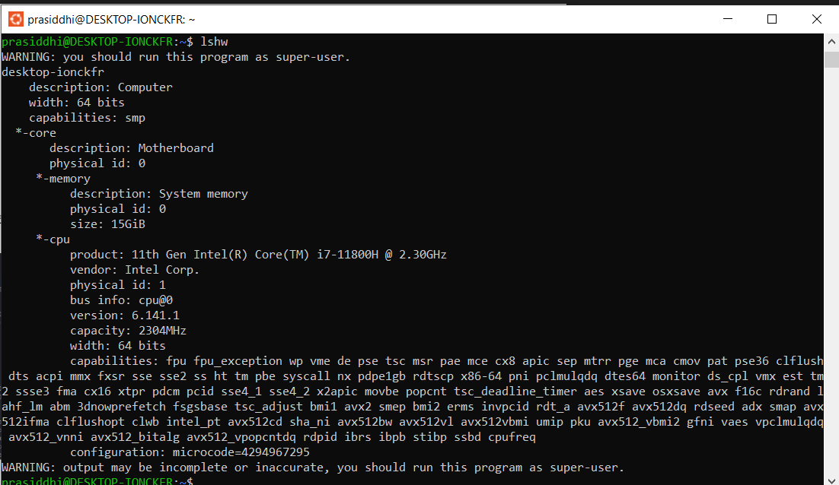

**2. lshw**

Interpretation: extract detailed information on the hardware configuration of the machine.

Output:

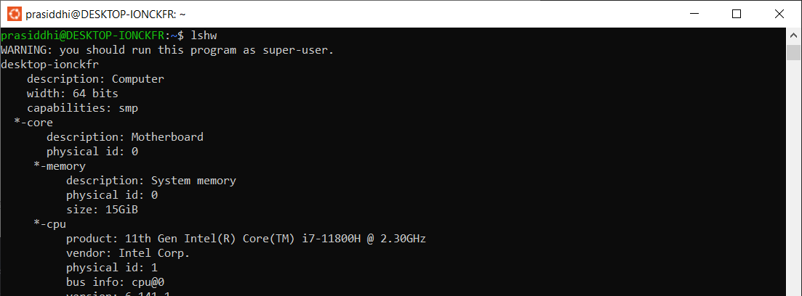

**3. sudo lshw**

Interpretation: extract detailed information on the hardware configuration of the machine.

Output:

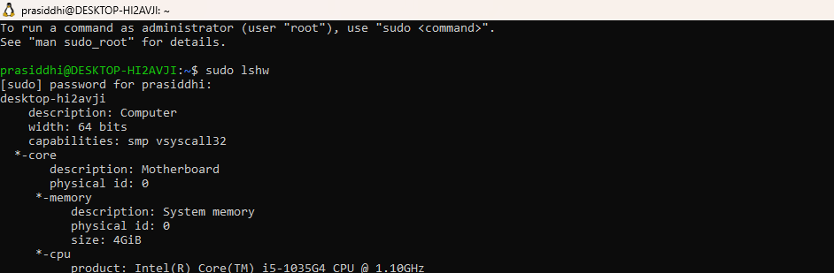

**4. lsusb**

Interpretation: displays information about USB buses in the system and the devices connected

to them. It uses udev's hardware database to associate a full human-readable name

to the vendor ID and the product ID.

Output:

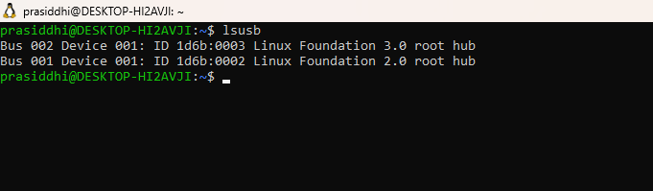

**5. lsblk**

Interpretation: lists information about all available or the specified block devices.

Output:

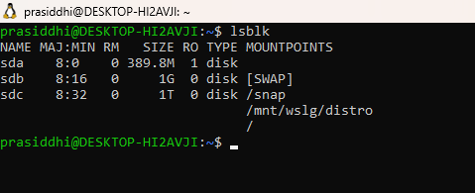

**6. df**

Interpretation: displays the amount of space available on the file system containing each file

name argument. If no file name is given, the space available on all currently mounted

file systems is shown.

Output:

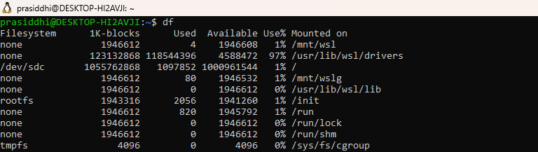

**7. free**

Interpretation: Display amount of free and used memory in the system

Output: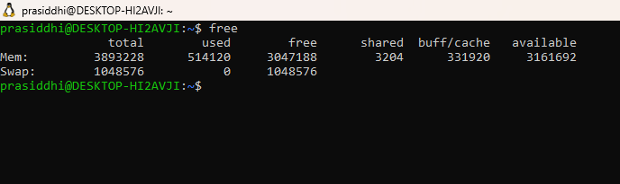

**8. hdparm -i /dev/sda**

Interpretation:provides a command line interface to various kernel interfaces supported by the

Linux SATA/PATA/SAS "libata" subsystem and the older IDE driver subsystem

Output:

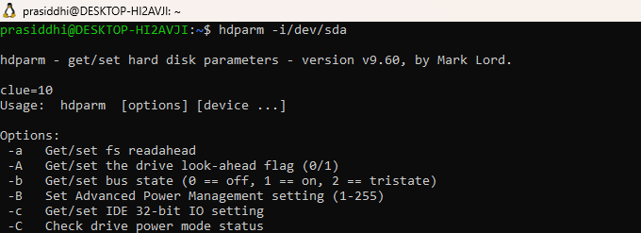

**9. uname**

Interpretation: prints the system information

Output:

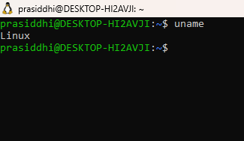

**10. uname -n**

Interpretation: prints the network node hostname

Output:

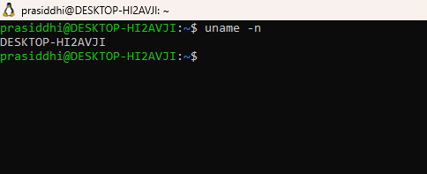

**11. uname -v**

Interpretation: print the kernel version

Output:

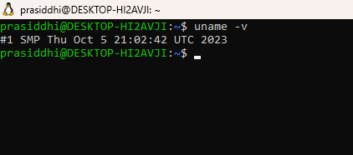

**12. uname -r**

Interpretation: print the kernel release

Output:

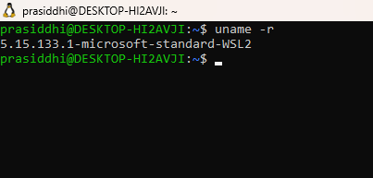

**13. uname -m**

Interpretation: print the machine hardware name

output:

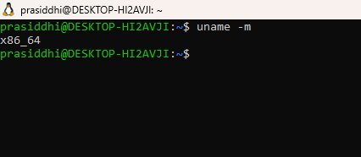

**14. uname -a**

Interpretation: print all information like kernel name, network node hostname, kernel release

and version, machine hardware name, processor type, etc.

Output:

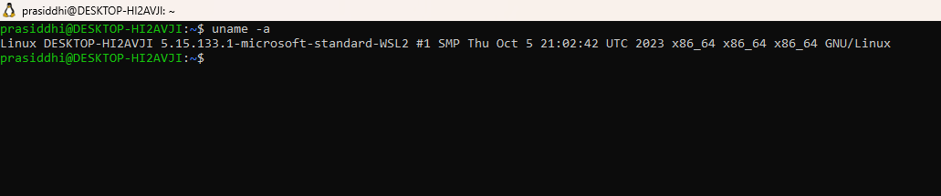

**15. factor 1203343**

Interpretation: print the prime factors of the given numbers, either given from command line

or read from standard input

Output:

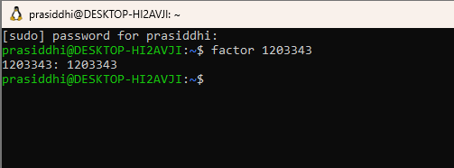

**16. id**

Interpretation: print real and effective user and group IDs

Output:

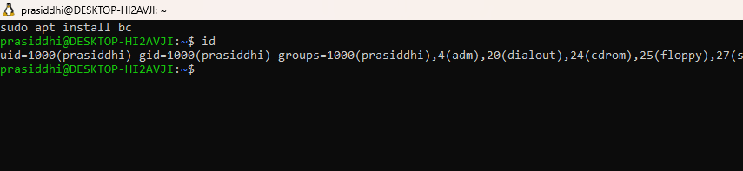

**17. lsusb | tee lsusb.txt**

Interpretation: lsusb outputs all the usb devices and ‘|’ symbol redirects the output of lsusb

into file lsusb.txt

Output:

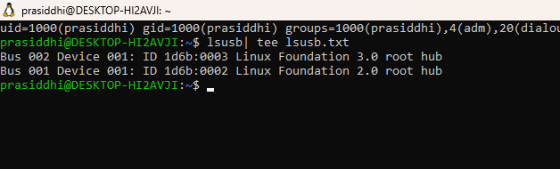

**18. cat lsusb.txt**

Interpretation: reads the file lsusb.txt

Output:

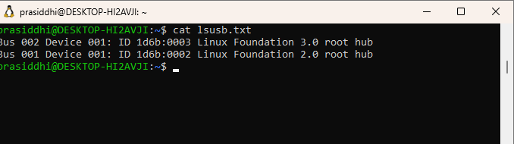

**19. ping -w 3 google.com**

Interpretation: send ICMP ECHO_REQUEST to google.com

Output:

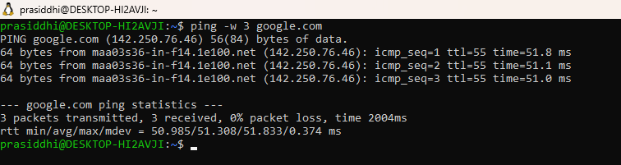

**20. sudo tcpdump**

Interpretation: prints out a description of the contents of packets on a network interface

Output:

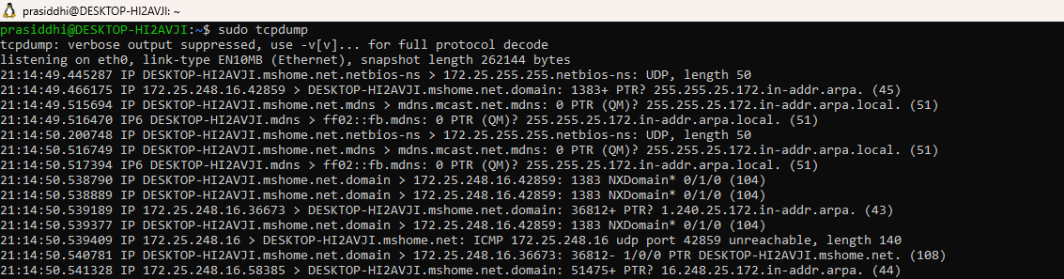

**21. host google.com**

Interpretation: performs DNS lookups. It is normally used to convert names to IP addresses and

vice versa.

Output:

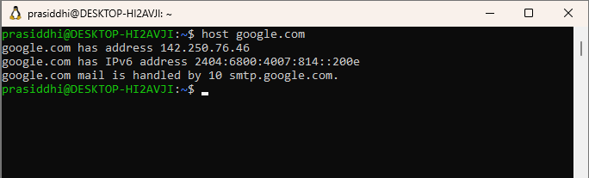

**22. tracepath achsnepal.edu.np**

Interpretation: traces path to a network host discovering MTU along this path

Output:

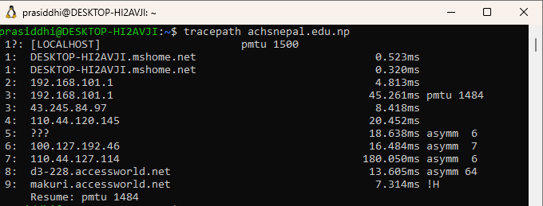

**23. nslookup achsnepal.edu.np**

Interpretation: query Internet domain name servers interactively

Output:

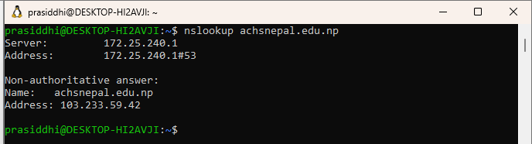

**24. sudo apt-get update**

Interpretation: resynchronize the package index files from their sources.

Output:

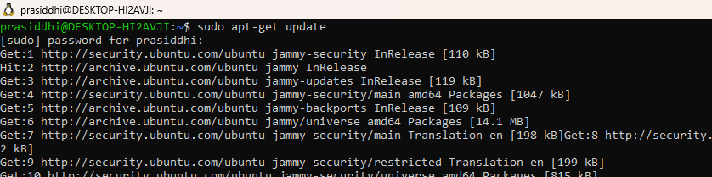

**25. sudo apt-get upgrade**

Interpretation: install the newest versions of all packages currently installed on the system

from the sources enumerated in /etc/apt/sources.list

Output:

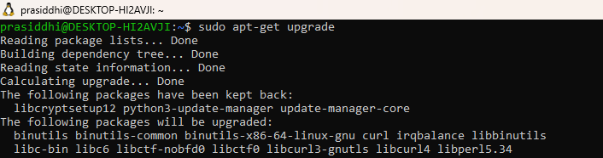

**26. sudo apt-get install sl**

Interpretation:install package sl

Output:

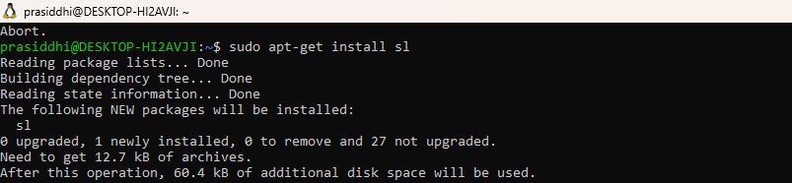

**27. sl**

Interpretation: display animations aimed to correct users who accidentally enter sl instead of

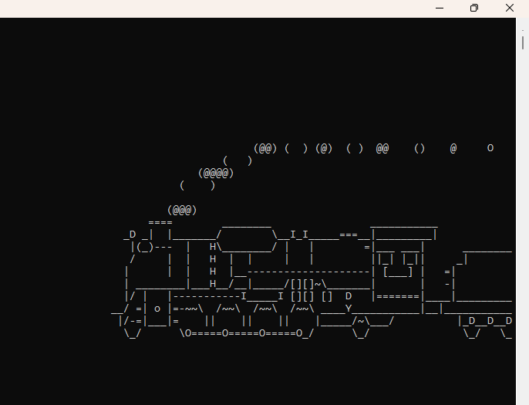

**28. ls**

Output:

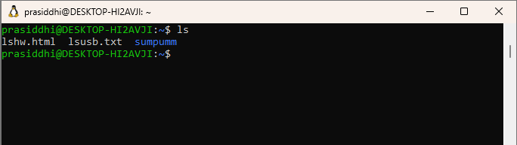

**29. exit**

Interpretation: exit the current program